Patrick D. Duggan, Eric B. Goff;Garrett D. Hart;Thomas J. Kline;Chris A. Salim

FAMU-FSU College of Engineering  2525 Pottsdamer St. Tallahassee, FL. 32310

Team 12: NASA-MSFC Tesla Pump

2/16/2018

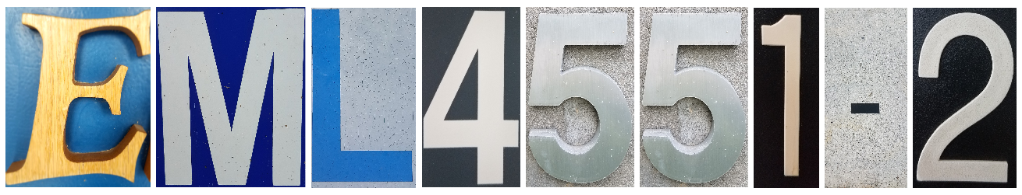

# Abstract

As an underdeveloped technology, the Tesla pump is being explored for use within aerospace applications to help minimize the loss of expensive fuel, which serves as the motive of this project. Bladed pumps produce a large pressure difference across the blades. This pressure difference can cause cavitation, which results in energy loss through wasted fuel. A Tesla pump uses the boundary layer effect and the viscosity, a fluids resistance to flow, to transmit momentum from the pump’s disks to the fluid. By controlling the space between each disk and the rotational speed of the disk stack, different flow rates and pressure rises can be met. The lack of major pressure differences in a Tesla pump minimizes cavitation conserving fuel in costly aerospace applications. The lack of research on Tesla pumps has lead NASA to desire relationships between flow rate and pressure rise versus disk spacing and rotational speed as mentioned above. NASA-Marshall Space Flight Center would like a Tesla pump that can: produce a 15 gallon a minute flow rate, a pressure rise of 5 psi, and fit through a 4 inch diameter hole to be used on a preexisting tank. The project deliverable includes finding out correct disk spacing and rotational speeds for operation in water and extremely cold fluids. Last, relationships determined for disk spacing and pump rotational speed will be used to further develop a final Tesla pump design.

.

# Disclaimer

# Acknowledgement

Table of Contents

Abstract ii

Disclaimer ii

Acknowledgement ii

List of Tables ii

List of Figures ii

Notation ii

Chapter One: EML 4551C 2

1.1 Project Scope 2

1.2 Customer Needs 2

1.3 Functional Decomposition 3

1.4 Target Summary 3

1.5 Concept Generation 4

Concept 1. 4

Concept 2. 4

Concept 3. 4

Concept 4. 4

Concept n+1. 4

1.6 Concept Selection 4

1.8 Spring Project Plan 4

Chapter Two: EML 4552C 5

2.1 Spring Plan 5

Project Plan. 5

Build Plan. 5

Appendices 6

Appendix A: Code of Conduct 7

Appendix B: Functional Decomposition 12

Appendix C: Target Catalog 13

References 14

# List of Tables

# List of Figures

# Notation

|  |  |
| --- | --- |
|  |  |
| dB | Decibel |
| ESA | European Space Agency |
| FAMU | Florida A&M University |
| FSU | Florida State University |
| gpm | Gallons per minute |
| hp | Horsepower |
| MSFC | Marshall Space Flight Center |
| psi | Pounds per square inch |
| rpm | Rotations per minute |
| Thou | Thousandths of an Inch |
|  |  |
|  |  |

# Chapter One: EML 4551C

## 1.1 Project Scope

**Description.**

Develop a Tesla pump for use within tank propellant mixing and transfer to help minimize the presence of cavitation, reducing cryogenic boil off.

**Key Goals.**

The key goals for this project can be categorized into two distinct groups, major and minor goals. The major goals will permit the design to achieve its full operational purpose while the minor goals serve to optimize the complete design. Listed below are the two groups and the corresponding goals in each.

Major Goals:

* Design and build testable Tesla pump prototype
* Achieve desired pressure rise
* Achieve desired flow rate
* Operational with given flange
* Meets size constraints

Minor Goals:

**Primary Market.**

The primary market for this project includes NASA–MSFC, who has provided the team with the opportunity to work on such project. Additionally, other agencies who would desire a pump that uses viscous forces, as opposed to blades, to help minimize the presence of cavitation serve as primary markets as well. Examples of these agencies would include other government or private aerospace organizations like ESA and SpaceX.

**Secondary Market.**

Secondary Markets for the Tesla Pump project include any other industries related to fluid dynamics where a pump may be needed and used. Another notable industry that exists as a secondary market includes the biomedical industry. As tesla pumps are used to pump blood in a human body, this project may serve to provide additional information to help optimize tesla pumps used in this market.

**Assumptions.**

To complete this project in a timely manner, there are a few assumptions that will need to be made. First, the team will assume that water is a suitable fluid choice for operational simulation and gathering data. Second, corrosion and other degradation factors can be mostly ignored. Lastly, the team will only vary disc spacing and not disc size. By only adjusting one variable, it will help the team determine a correlation between disk spacing and output.

**Stakeholders.**

The stakeholders for the Tesla Pump project include NASA–MSFC and FAMU-FSU College of Engineering. From NASA-MSFC the team’s two engineering liaisons are James Martin and James Smith. At FAMU-FSU College of Engineering, Dr. Shayne McConomy and Dr. Chiang Shih serve as the department advisors, while Dr. Lance Cooley is the project advisor.

## 1.2 Customer Needs

**Project Brief.**

Tesla pump technology involves stacking flat disks with small gaps between each disk to serve as a turbine to pump fluid. The customer needs a way to efficiently mix and transfer the fluid in the tank to ensure the fluid does not become stagnant. The sponsor desires a low rpm for the turbine disks that still yields an efficient output power to rpm ratio. The ratio of power input to rotation of turbine disks necessary to achieve 15 gpm flow rate with a relative pressure rise of 5 psi is important to the project operation and serve as operation benchmarks. The pump system will be attached to the flange provided by NASA-MSFC. Liquid nitrogen is the desired working fluid in the system. Testing will also be done with water as a demonstration of the working tesla pump. Ultimately a relationship between disk spacing and mixing efficiency will be determined.

**Customer Needs.**

|  |  |  |
| --- | --- | --- |
| **Question/Prompt** | **Customer Statement** | **Interpreted Need** |
| Are there certain motor specifications that must be met? | Motor may be provided if there is an accessible one from the previous senior design group or one at MSFC that would suffice. Otherwise, it is the team’s responsibility to find and obtain an appropriate motor. | Motor needs to be chosen attempting to balance power and speed. |
| What will be the budget for this project? | University has estimated to be around $500. | The design should cost no more than $500. |
| What are the rpm specifications? | The pump’s efficiency is the most important thing when taking rpm with respect to the energy required to operate the system into consideration. | Pump efficiency is the main priority. |
| As far as programs to simulate the Tesla pump, is there a preferred program, or is it up to the team’s discretion? | The team may use whatever modeling/simulation software that they are most familiar with. | Generating the desired models is more important than which program is used. |
| What are the size constraints? | It is desired that the pump is easily mounted onto the flange (An 8” 304L SS Conflat flange would be an ideal base). The assembly fits through a 4” diameter hole if possible. | The assembled design attaches to an 8” 304L SS Conflat flange and strives to fit through a 4” diameter hole. |
| What are the weight constraints? | Weight has no real constraint because this will be a prototype, although the sponsor would like to minimize weight. If a heavy part is used, make sure to make note of that part for future reference. | As long as there are no excessively heavy parts, weight constraint can be somewhat ignored |
| Will any other fluids be involved besides water? | The prototype will be tested with water; however operational models of liquid nitrogen are desired. | The design operates to design conditions with water and liquid nitrogen (or liquid nitrogen stimulant). |
| What environment will this pump be exposed to that the team should take into consideration when designing? | Materials must be liquid nitrogen compatible. | Materials must be liquid nitrogen compatible. |
| Which units are preferred? | Units are designer’s preference. | Use group preferred units. |

## 1.3 Functional Decomposition

**Tesla Pump Functional Decomposition.**

Functional decomposition is a tool used to help break down a system into smaller more manageable parts. When performing a functional decomposition, it is important to remember to describe desired physical actions and outcomes; not to specify potential solutions, components, or equations (McConomy, 2017). In general, these phrases begin with a verb, which implies an action. Lastly, the phrases should use common everyday language so that these functions can be further broken down into tasks. Below is the functional decomposition for the tesla pump used for fluid mixing and transfer.

* Convey working fluid around containment vessel
* Enable fluid mixing
* Disperse heat through fluid mixing
* Steady rotating components
* Attach to desired surfaces
* Adjust working fluid
* Control flow of working fluid
* Discern relationship with disk spacing
* Consume minimum amounts of power
* Channel working fluid to/from disks
* Detach from system when desired
* Spin disk stack
* Allow viscous forces to act on fluid

Figure 1 and Figure 2 below depict the relationship between the functions and the design components of the tesla pump.

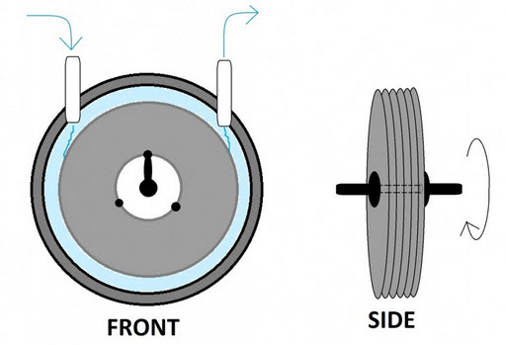

Outlet

Steady rotating components

Spin disk stack

Closed

Outlet

Convey working fluid

Control flow of working fluid

Channel working fluid to/from disks

Enable fluid mixing

Adjust working fluid

Allow viscous forces to act on fluid

Inlet

Housing

Stacked

Disks

Inlet

Figure 1: Tesla Pump Front and Side Views

Force Vector

Closed

Outlet

Outlet

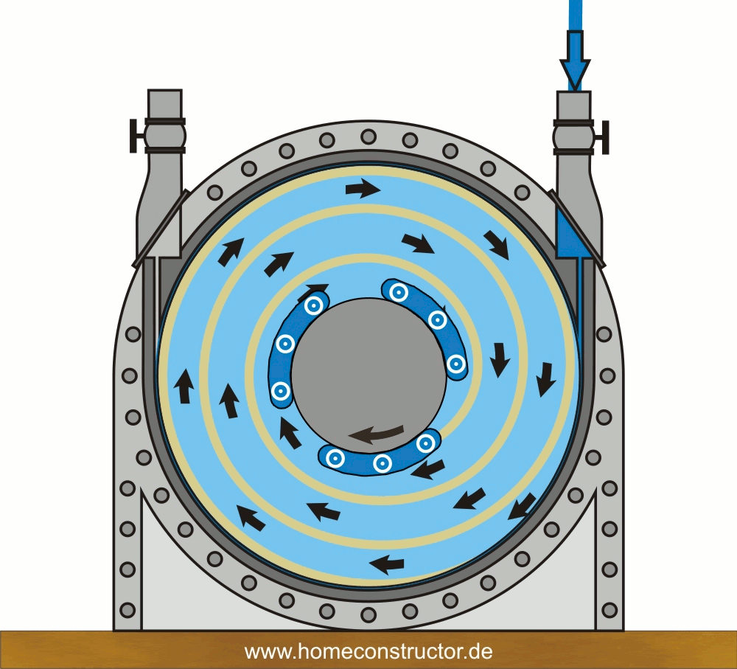

Design

Functions

**Key**

**Objectives**

Disperse heat

Attach to desired surfaces

Detach from system when desired

Discern relationship with disk spacing

Inlet

Figure 2: Detailed Top-Side View

## 1.4 Target Summary

The targets for this tesla pump system will mostly be affected by the generation of a volumetric flow rate of 15 gallons per minute with a pressure rise of 5 psi. For purposes of mounting the pump on a preexisting design, it is important that the overall outside diameter be no more than 4 inches. By accomplishing such, the entire pump system will be able to mount directly onto an already designed 8-inch conflat flange and fit inside the propellant tank, where it may perform its functions. The variables being adjusted to meet the targets are the disk spacing and thickness in a range of 1 thousandths to 10 thousandths of an inch, the hole pattern punched into the disk, the number of disks used in the pump system, and the rpm of the disks ranging from 6,000 to 10,000 rpm. The selected values of rpm are derived from research that indicates a correlation between increased rpm and greater pressure rise of a Tesla pump; and the provided motor, Bodine 34B4BEBL, that has a maximum speed of 10,000 rpm. The revolutions will be governed by the current being run to the motor while it is turned on to determine an optimal speed for pump performance. The disk spacing will play a pivotal role in performance as the pump operates using viscous forces to move the fluid. Something to consider will be the effect of rpm on the height of the boundary layer, as optimal thickness between the disk is twice the boundary layer height. Knowing the height of the boundary layer present on each disk at a given rpm will enable a more appropriate disk spacing to be chosen.

As disk spacing is being varied, there are ranges for some of the other values. By having the ability to adjust the testing apparatus, the results can be used to develop correlations to how the adjustments affect the results. The relationship with disk spacing is desired; and as disk spacing changes other parameters will have to change as well to keep the 15 gpm flow rate and 5 psi pressure rise that is desired. A specific example of this concept is the use minimal power target. A 1/3 hp motor is going to be used, however depending on the disk stack and other design choices made the entire output of the motor may not be needed. Another example of how the disk stack changes the operation of the design is in the beginning start up. Depending on the design choices selected a slow or fast ramp up to steady state speeds should be used.

Lastly, a way to measure if the disk stack is spinning correctly (not vibrating) is needed. Here our group decided to take advantage of the fact that a vibrating disk stack would make a lot of noise. After some research a value of ~60 dB was found to be the average value for a loud conversation (as in a crowded place). Using a sound measuring device at the Maglab the team will ensure proper balance of the disk stack by ensuring the vibrations are not disruptive as disruptive vibrations would cause noise over the given limit.

## 1.5 Concept Generation

As a part of the preliminary design phase, the generation of multiple designs concepts is crucial. Achieving the target values needed in this project requires a robust design that takes all aspects of the tesla pump into consideration. In this section, overall design concepts are introduced and then the most basic components of the pump are broken down and multiple designs of each component are explored. With multiple design possibilities for each component, the pros and cons of each component’s design are discussed and the selection of concept will be made easier. Multiple concepts for each component of the pump came from a result of group ideation. As a whole, the group discussed a quantitative amount of design for each component based on previously published research and studies. It was concluded that the six components that could vary in design were as follows: holes in the disks, inlet design, disk spacing, outlet design, and shaft geometry and bearing selection.

**Overall Concept 1.**

The first overall design concept of the Tesla pump can be visualized in Figure 3 below. 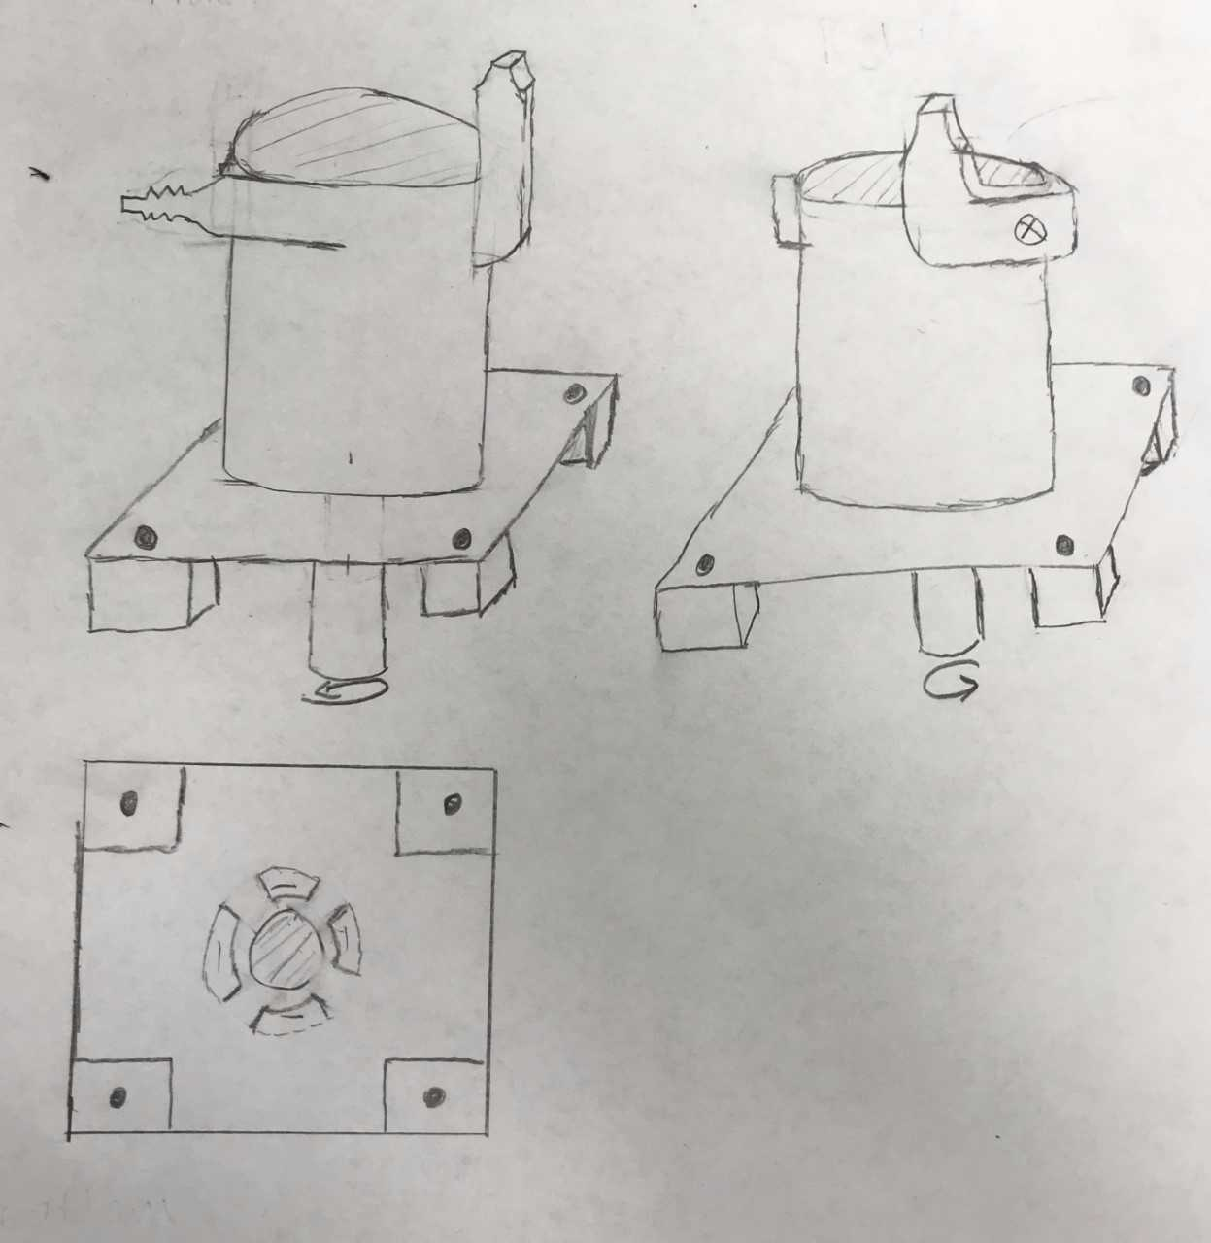

Anchor Point

Right

Front

Shaft

Outlet

Inlet

Outlet

Bottom

Figure 3: First overall concept idea for Tesla pump

In this design the objective is to create an efficient tesla pump system using common cylindrical housing designs for tesla pumping systems. First the housing will have anchor attachments located at the bottom to secure it to the flange. The disks will be in the center of the housing to promote disk stability and steady rotation. For the housing inlet it will be centered on the shaft where the shaft enters at the bottom of the housing. This inlet position is optimal because the fluid needs to enter through the center, then the centripetal force will push the fluid out. The disks will drive the fluid up and out through the outlet located on the side of the top of the cylindrical housing. Having the outlet flow upwards will help ensure that proper propellant mixing occurs in the tank. To do this the outlet will incorporate vanes within the upward turn to keep fluid separation to a minimum and head loss low. Also, it is known that rectangular nozzles allow jets to promote better fluid mixing so the outlet nozzle will be rectangular. To make the disks that will be used in the pump a thin sheet of metal will be punched out with a stencil. The disk spacers will be made from the same material as the disks and punched out with a press as well. If disk thickness or gaps need to be increased multiple disk or spacers will be stacked together. The shaft the disks will rest on will be of a gear nature with a teeth pattern along the circumference. The shaft the disks set on will have a bearing on both ends that resides inside the housing to keep disks stable. The disks will be tightened down with a reverse threaded nut so that the torque generated by the motor doesn’t unscrew it while it is spinning.

**Overall Concept 2.**

Another concept created implements the idea of using a cantilever style mounting system with both bearings being situated below the disk stack. This can be visualized in following figure, Figure 4.

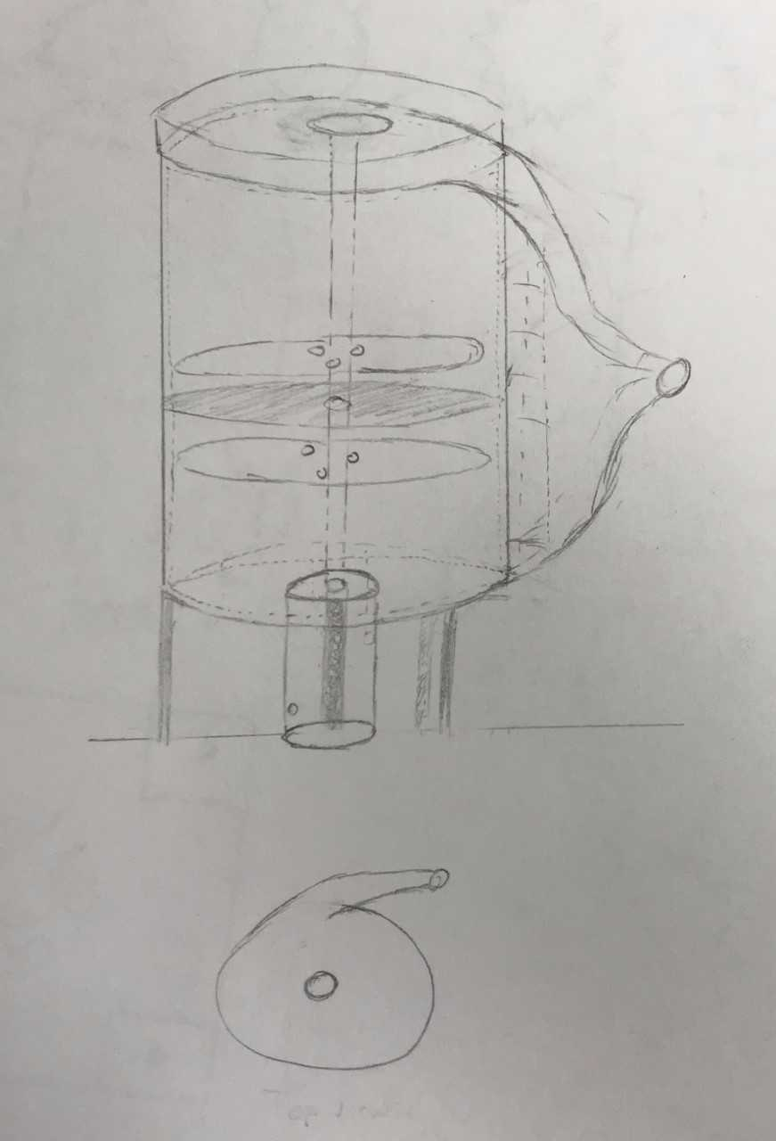

Anchor Point

Top

Inlet

Front

Outlet

    Figure 4: Second overall design concept for Tesla pump

The above design includes the idea of having two inlets, one on the bottom and one on the top of the housing. The top inlet would be sloped inward to help direct the flow through the entrance. A con to multiple inlets includes that it may work exactly opposite of the desired manner, and could potentially become an outlet. At an optimal point, there would be a solid disk without holes for fluid to flow through. This would cause all the fluid that comes in contact with this disk to be forced towards the edges and be pushed out the outlet nozzle. By having the structure of the disk stack be cantilever style, this would permit the top inlet to be closest to the center and the fluid pick up more energy from the rotating disks as it is expelled outward. A potential concern with this design would include the idea that the disk stack may wobble since the mounting is only distributed on one side, unless this is properly considered. Also, the housing would slightly expand outward to direct the flow through the nozzle and permit smooth transition reducing losses in the flow.

**Disk Hole Design Concepts**.

The holes that are oriented evenly about the center of the disks and housing intake play a significant role in the way that the water moves between the disks and is eventually propelled through the outlet. The size and shape of the holes also affect weight as well as the prevalence of the boundary layer effect between the disks. Larger holes will decrease the amount of material and weight while also decreasing the boundary layer effect, hence sacrificing efficiency. It will be optimal to find the best balance of hole shape and size to the desired amount of needed surface area. Also seen in Figure 5-d, a series of notches around the circumference of the disks. The use of these can be coupled with another one of the inner hole designs. Also using more holes of each respective style would be possible further along the diameter.

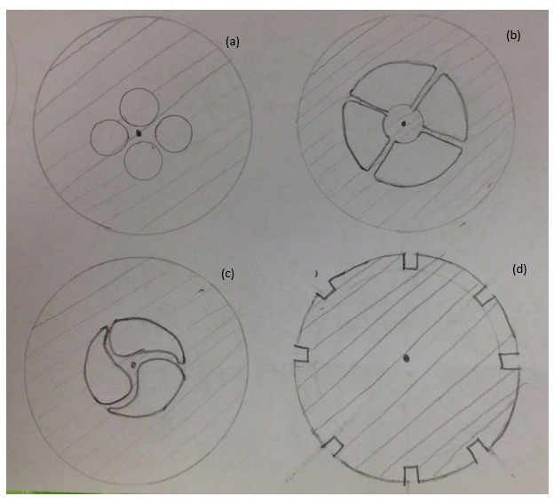

Figure 5: Possible disk hole and housing inlet designs.

There are advantages and disadvantages to each design. The first two inner diameter holes, see in (a) and (b), would be significantly cheaper to manufacture than would be for (c). However, (c) would create a vortex phenomenon naturally with less initial torques due to the unique teardrop design. Also, the holes around the circumference, in addition to center holes, would likely be used, seen in (d), due to a channeling effect that occurs around the circumference. If a gear type shaft is ultimately used, the disk stacking can also be staggered and the helical shape that the notches would create produce more torque at relatively low rpms. It is also important to note that the size and shape of the intake on the housing will likely be the same shape and size as the holes on the disk. This will help avoid unneeded strain on the housing and disks that would be produced if the fluid had to either expand or contract moving from the intake to the disks.

**Disk Stack Concept**.

One of the most important aspects of the design is the disk stack. This aspect is crucial as the disk stack is directly related to the efficiency, volumetric flow rate of the liquid, and pressure rise. The sponsor also desires a relationship of the spacing between the disks and the ability to mix or transfer the fluid. To accomplish the goal given by the sponsor, a design with a variable disk stack is needed. A “variable end” design concept was conceived to give the team control over the spacing between the disks. The “variable end” design consists of three main components: an ending disk stack, spacers (washers), and the disks. The disks and spacers work together to create a specific disk spacing by placing different amounts of washers between two disks. Alternatively, to obtain even more control of the disk spacing the spacers and disks themselves could be made thinner or thicker and then the same “variable end” technique is applied. Finally, the ending disk stack is a collection of disks that can be added to the ends so that the overall length of the stack is the same for all cases. One good feature about this design is, if the length of the shaft is changed part of another disk stack can be added or a fraction of the original removed.  Figure 6 below shows an example of how the “variable end” design can be used to create any disk spacing desired.

|  |  |  |  |  |  |  |  |  |  |  |  |  |  |  |  |  |  |  |  |  |  |  |
| --- | --- | --- | --- | --- | --- | --- | --- | --- | --- | --- | --- | --- | --- | --- | --- | --- | --- | --- | --- | --- | --- | --- |
|  |  |  |  |  |  |  |  |  |  |  |  |  |  |  |  |  |  |  |  |  |  |  |
|  |  |  |  |  |  |  |  |  |  |  |  |  |  |  |  |  |  |  |  |  |  |  |

|  |  |  |
| --- | --- | --- |
|  |  |  |
| Ending Disk Stack | Spacers | Disks |

Figure 6: “Variable End” Design Example

**Outlet Nozzle Concepts**.

In Figure 7 below the assorted designs for the outlet nozzle are observed and considered for the best functional option for directing the flow of the fluid out of the pump and the propellant mixing required of the system.

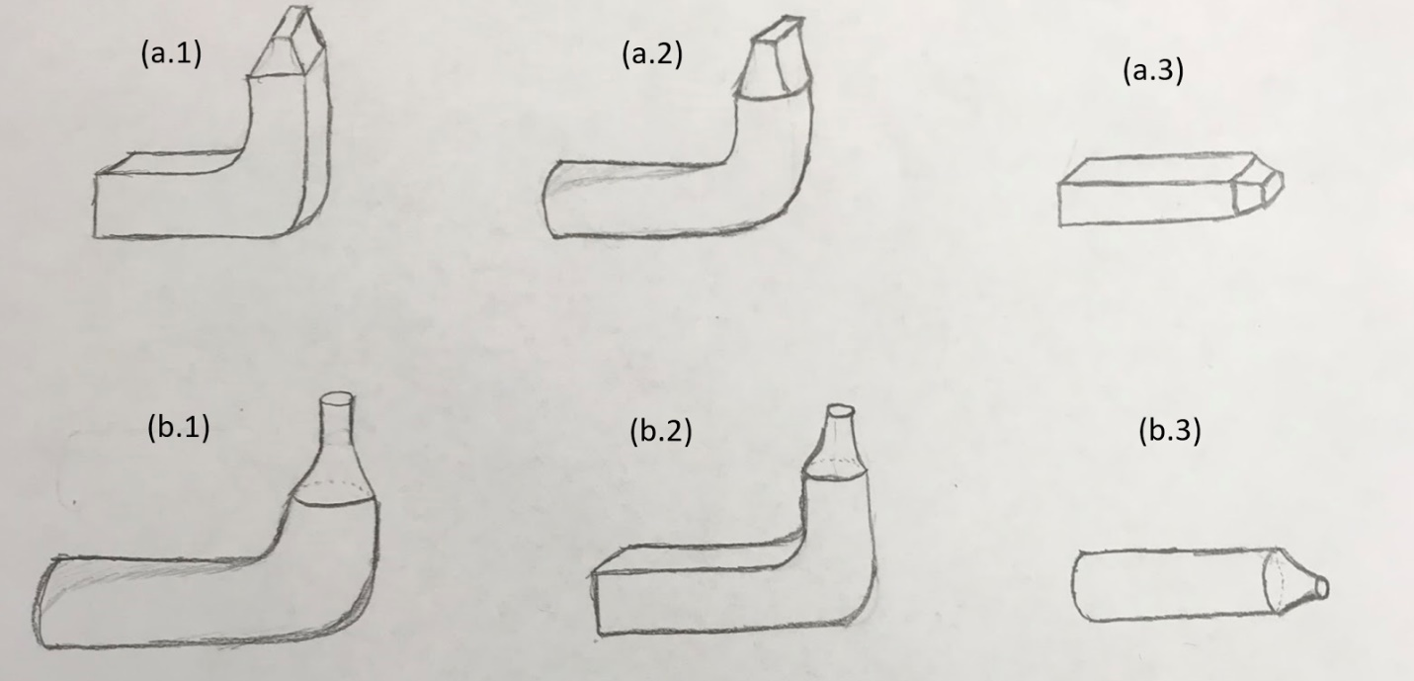

Figure 7: Variations of Outlet Designs a and b

The disks will drive the fluid up and out through the outlet located on the side of the cylindrical housing. Because the fluid is driven by the centripetal force provided by the rotating disk the fluid will need to be directed and focused. The outlet needs to focus the flow so that proper propellant mixing occurs in the tank. One way to do this the outlet will make a 90 degree smooth curve in the vertical direction and incorporate vanes at the bend to keep fluid separation to a minimum so that head loss remains low. The second method is to just expel the fluid out the side of the housing.  Also, it is known that rectangular nozzles allow jets to promote better fluid mixing, so the Figure 7-a design outlet nozzle will be rectangular. The length of the outlet shape is being considered as well for this nozzle, two designs being observed are a circle and rectangular cross-sectional area. The second outlet design is a normal circle pattern the stream will be focused through. This pattern is more optimal for the pressure rise as the fluid comes together more evenly. This circular design will follow the same flow layout as the rectangular configurations, with one focusing the flow vertical with a smooth 90 degrees turn and the other following the natural flow of the fluid as it is pushed out horizontally with the centripetal force.

Each outlet nozzle has its own advantage and disadvantages. In figure 7-a series the rectangular nozzle promotes better mixing however it is harder to manufacture. The figure 7-b series is easier to manufacture and creates better pressure rise than the 7-a series, however, it does not promote the same level of fluid mixing.

**Shaft Concepts.**

The shaft of the Tesla pump serves to use the rotational energy produced by the motor and spin the attached disks. Ensuring a proper connection of the disks will prevent slip between the surfaces and allow the maximum amount of energy to be transmitted. Factors that will need to be evaluated include stresses seen between the two surfaces, durability, symmetry of the design, and manufacturability. Below in Figure 8 includes a few potential middle of shaft configurations that would allow for proper transmission of energy from the motor to the disks. Included in these designs are the idea of keyed shafts and shafts with gear teeth.

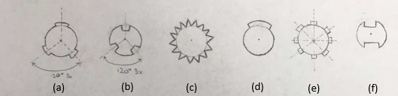

    Figure 8: Various shaft design concepts

In the above figure there includes six different potential center of shaft designs looking from top down. Shaft designs (a), (b), (c), (e), and (f) all possess symmetry, as opposed to shaft design (d), which will help minimize vibration experienced when rotating at high speeds as well as reduce stresses on the shaft.  Shaft designs (b) and (f) make use of an internal keying design while the rest of the concepts use external key features. The teeth design will be determined by understanding the forces that will be exerted on the disks and the required strength of the teeth while ensuring manufacturability or availability of commercial off the shelf products.

**Bearing Concepts.**

Three different types of bearings are being considered to connect the shaft with the housing in a way that will minimize friction, seen below in Figure 9.

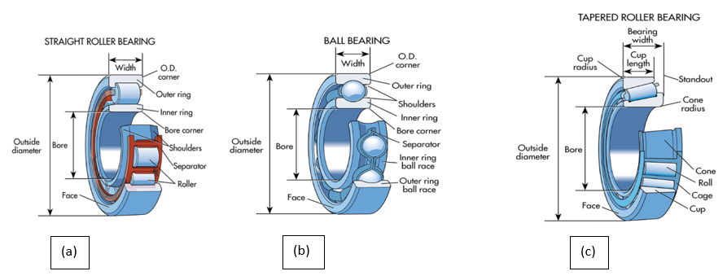

(c)

(a)

(b)

Figure 9: Three bearings being considered

The straight roller bearing (a) employs cylindrical rollers that make contact with the outer ring of the bearing. Due to the larger area of contact, these bearings are well-suited in applications where radial force is high. Tesla Pumps may experience substantial amounts of radial load due to the high-speed spinning of the disks causing centripetal force. However, they are not the best equipped to handling axial forces, which will be present due to the perpendicular fluid flow. Tapered roller bearings (c) provide a better balance of axial and radial resistance, depending on the angle of tilt of the bearings, which may prove useful. However, the loads the bearings experience may not be high enough to cause concern, therefore a ball bearing (b), being the cheapest, may be the best option.

**1.6 Concept Selection**

In order to determine the most ideal design for this project, a scientific approach must be used in order to weigh the benefits of choosing one design concept over another. Each component was analyzed and put into its own Pugh Matrix. The Pugh Matrix makes it easy to justify each component selection by weighing the benefits and flaws of each design by assigning a number value to each category being graded for the part. The numbers assigned under each category are justified by the background research conducted or on formulation of the system. Each rating for the Pugh Matrix was made using a 0-5 scale, where 0 is the worst and 5 is the best for a given category. The largest total then tended to be selected as the better, more effective concept.

**Housing Component Selection.**

In the first section of concept selection, every aspect of the two overall design concepts initially considered must be evaluated. The four main differences seen in these two designs are the inlets, outlets, bearing locations, and housing types. The initial discussion of the overall design concepts to be chosen will focus on the idea of using one or two inlets as seen in Figure 10 below.

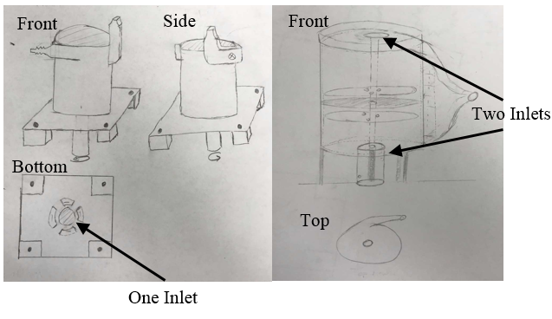

Figure 10: (left) Overall Design Concept 1 Inlet, (right) Overall Design Concept 2 Inlets

With the goal to obtain a relatively large volumetric flow rate for a Tesla pump, maximizing the fluid intake is a priority. Table 1 illustrates the differences between having one or two inlets with the effectiveness being a main focus of the design.

Table 1: Housing Selection - Inlet Pugh Chart

|  |  |  |  |  |  |  |
| --- | --- | --- | --- | --- | --- | --- |
| Housing Selection - Inlet | | | | | | |
| Part Name | CCost | Durability | Weight | Manufacturing Time | Effectiveness | Total |
| One Inlet | 33 | 0 | 3 | 2 | 3 | 11 |
| Two Inlet | 33 | 0 | 4 | 2 | 5 | 14 |

Looking at the cost, each design will be similar as both ends will start as solid pieces and the one or two inlet holes will be machined into the housing ends. Also, durability is not considered as that will be a property of the material selection seen in Table 10, later in this section. Since the inlets will simply be holes on the ends of the housing, having less weight will be a result of more holes, thus the two inlets will be lighter than the one inlet. The effectiveness is a measure of how well the overall project goal will be able to be achieved by using the selected number of inlets. As the project requires a relatively high volumetric flow rate, use of two inlets can help achieve larger volumetric flow while still avoiding undesired pressure difference within the pump. Additionally, the use of two inlets would permit there to be a solid disk in the middle of the stack that would cause the one complete pump to act like two adjoined Tesla pumps. Due to the increased effectiveness, and negligible other differences, the preliminary design will be constructed using the dual inlet concept.

The next aspect of the overall concept to be analyzed, is the number of outlets that are used. The initial project scope requires a robust design that mixes and transfers fluid. Having two functions is the reasoning behind the two outlet design. It was also considered that one outlet could be used and the fluid be redirected in order to both transfer and mix fluid. The two ideas can be seen if Figure 11 below.

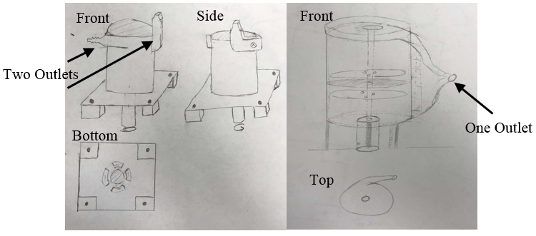

Figure 11: (left) Overall Design Concept 1 Outlets, (right) Overall Design Concept 2 Outlets

The tesla pump will benefit most from the design that focuses on the effectiveness of moving the fluid through the system and also the cost, considering a relatively low budget. The weight and manufacturing time must also be considered. All can be seen in Table 2 below.

Table 2: Housing Selection - Outlet Pugh Chart

|  |  |  |  |  |  |  |
| --- | --- | --- | --- | --- | --- | --- |
| Housing Selection - Outlet | | | | | | |
| Part Name | CCost | Durability | Weight | Manufacturing Time | Effectiveness | Total |
| One Outlet | 55 | 0 | 3 | 4 | 4 | 16 |
| Two Outlet | 33 | 0 | 2 | 2 | 3 | 10 |

The cost of the two outlet idea will be significantly larger than the one outlet, based on the fact that twice as many outlets will cost roughly twice as much. The durability is also not considered as it is a function of the material selection as stated before. The weight category will also favor the one outlet as the two outlet system will be inherently heavier. For the manufacturing time, the two outlet system will take longer for two reasons. The two physical outlet nozzles will take longer to design and manufacture, the same is true for the design of the physical housings, as being compatible for two outlet nozzles will require a more complex design than for one outlet. Lastly, the effectiveness of the one outlet will be higher from the more streamlined flow. Theoretically, if there are two outlets and one is closed off in order to control fluid direction, the possibility of stagnant fluid buildup where the outlet is closed is very probable, reducing effectiveness. After evaluation, it is determined that one outlet will be used.

Next, three different bearing configurations were considered: normal bearing locations on top and bottom, a cantilever design that had a bearing on the bottom of the housing and a bearing connecting the shaft to the tank wall, and then the third idea combined the two ideas. The third idea would incorporate three total bearings, one bearing at the top of the housing, one at the bottom of the housing, and one connecting the shaft to the tank wall. These various ideas can be visualized in Figure 12.

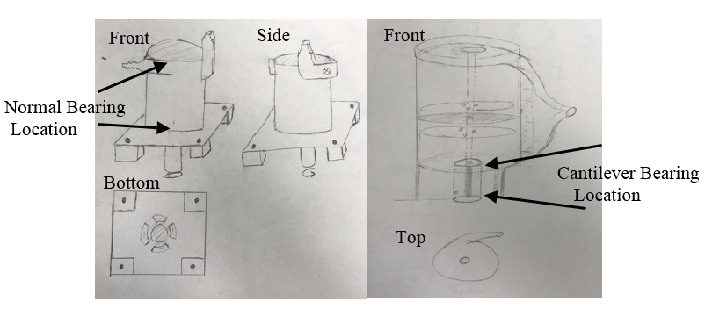

Figure 12: (left) Overall Design Concept 1 Bearing Locations, (right) Overall Design Concept 2 Bearing Locations

The three configurations are analyzed in Table 3. It is important that the shaft is properly constrained to the housing to ensure minimal vibrations and other disturbances. In addition, it is important to minimize the heat generated from friction.

Table 3: Housing Selection - Bearing Location Pugh Chart

|  |  |  |  |  |  |  |
| --- | --- | --- | --- | --- | --- | --- |
| Housing Selection - Bearing Location | | | | | | |
| Part Name | CCost | Durability | Weight | Manufacturing Time | Stability | Total |
| Cantilever Bearing Location | 33 | 2 | 3 | 0 | 2 | 10 |
| Normal Bearing Location | 33 | 3 | 3 | 0 | 3 | 12 |
| Combination | 22 | 5 | 2 | 0 | 5 | 14 |

The idea behind the cantilever style is that it would enable a single larger entrance to be focused in the top of the housing. After much deliberation, it was established that this concept would reduce the stability of the disk stack spinning at a high rpm due to uneven load distribution, thus resulting in a low rating in the stability and durability categories. Moving forward, having two bearings located on both the top and bottom of the housing was found to be more effective, yet not as effective as the combination of both of these ideas by means of using three bearings. It was determined that combining the two set-ups is the best solution. The planned design will thus have three bearings: one at the top of the pump, one at the bottom, and one connecting the shaft to the tank. This will cost and weigh slightly more since there will be more bearings, but the extra support will provide more stability and durability which outweighs the downsides.

Looking at the possible housing styles seen in Figure 13, the two ideas included use of a predominantly cylindrical housing and a divergent housing. While both ideas incorporate an overall cylinder for the housing, the meaning of divergent involves a gradual increase in the radius of curvature for the outlet connection, compared to the cylindrical housing with a steep 90° bend.

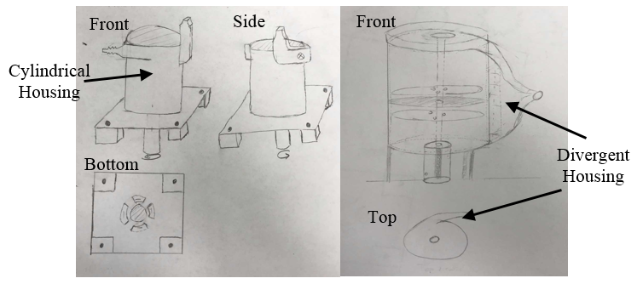

Figure 13: (left) Overall Design Concept 1 Housing, (right) Overall Design Concept 2 Housing

In Table 4 below, the benefits of using each design are compared.

Table 4: Housing Selection - Housing Design Pugh Chart

|  |  |  |  |  |  |  |
| --- | --- | --- | --- | --- | --- | --- |
| Housing Selection – Housing Design | | | | | | |
| Part Name | CCost | Durability | Weight | Manufacturing Time | Effectiveness | Total |
| Cylindrical Housing | 4 | 0 | 3 | 3 | 2 | 12 |
| Divergent Housing | 4 | 0 | 3 | 2 | 5 | 14 |

As it is important to sustain the fluid’s energy, the use of the divergent housing will allow the fluid to continue outward upon reaching the edges of the disks. By using the divergent housing, it will help reduce wasted energy from propelling the fluid against the housing wall and prohibiting it from continuing outward. This results in a substantially higher effectiveness for the divergent housing. Additionally, a gradual transition in flow direction will help minimize the pressure loss while the fluid is exiting the pump. Both weight and cost will be relatively similar for both, as the design does not vary the physical housing very much. The cylindrical manufacturing will however be more simplistic, reducing the time of manufacture.With all other factors between the two housings being relatively similar, the divergent housing will be chosen in the selected design.

**Disk Hole Selection.**

The next component evaluated were the physical holes that were to be machined onto the disks. As seen in Figure 5 before, there are four potential designs for the holes of varying complexity and location. The Pugh Matrix below in Table 5 displays the compatibility of each hole design. The one possibility not seen in Figure 5 is the combination of holes. This means that any of the first three possibilities, circular, rectangular or teardrop, would be combined with the circumferential notches.

Table 5: Disk Hole Selection Pugh Matrix

|  |  |  |  |  |  |  |
| --- | --- | --- | --- | --- | --- | --- |
| Disk Hole Selection | | | | | | |
| Part Name | CCost | Durability | Weight | Manufacturing Time | Effectiveness | Total |
| Circular Hole | 00 | 0 | 2 | 4 | 3 | 9 |
| Rectangular Hole | 00 | 0 | 3 | 4 | 4 | 11 |
| Teardrop Hole | 00 | 0 | 3 | 4 | 4 | 11 |
| Circumferential Notches | 00 | 0 | 2 | 4 | 1 | 7 |
| Combination | 00 | 0 | 5 | 4 | 5 | 14 |

In the above table it is first seen that the cost and durability of the disk hole design are not considered as both of these factors rely more on the material that was to be selected seen in Table 10 shown later. The weight will favor the combination of holes, as it will result in the least amount of total material. Also, the weight of both the rectangular and teardrop holes will be favored over the circular holes. This is due to the the size limitations of the circular holes, as both teardrop and rectangular holes allow for a narrow band of material between each hole and the circular does not, which has an hourglass shape between each hole. Also, the circumferential notches will not remove a lot of material as the size of each notch will be minimal. The manufacture time for each one will not vary between each disk as the process of either laser jetting or stamping will be relatively the same for each disk. For the effectiveness, the combination will be the best, as this design allows for a greater torque at lower rpm due to the notches. The notches by themselves, however, have the least effectiveness as they would not allow for the fluid to flow between the disks in the inlet and the pump wouldn't work. For the circular, rectangular and teardrop shapes, the effectiveness will be relatively the same, but the circular will be slightly less effective due to the fact that the area for the fluid to flow will be less, for the same reasoning as for the weight. After analyzing the data, it was decided that the final design will incorporate a combination of circumferential with the rectangular or teardrop holes. Both will likely be tested.

**Disk Stack Idea Selection.**

The two competitive ideas generated for creating the disk stack are the variable spacing and variable end designs. The variable spacing idea is simpler, and as one will see from the Pugh matrix below is the better choice. The variable spacing idea can be summarized as using different amounts of spacers between each disk. It is important to note that by using this idea the number of disks in the stack may change depending on the spacers. The variable end idea can be summarized as using disks of differing thickness on the end of the stack so that spacing can be changed while keeping number of disks and overall length constant. Table 6 below shows the Pugh matrix that was used when deciding between the two ideas.

Table 6: Pugh Matrix for Disk Stack Selection

|  |  |  |  |  |  |  |
| --- | --- | --- | --- | --- | --- | --- |
| Disk Stack Idea Choice | | | | | | |
| Idea Name | Cost | Durability | Replace ability | Weight | Manufacturing Time | Total |
| Variable Spacing | 5 | 3 | 5 | 4 | 5 | 22 |
| Variable End | 3 | 3 | 4 | 3 | 2 | 15 |

The variable spacing concept won in the cost category as there are less steps involved in creating the disk stack. In variable spacing, the only costs are materials and punching out the shape. Where the variable end has an additional manufacturing cost of creating the variable thickness end pieces. Durability is a tie as the materials will be the same for both ideas. Replace ability is a slight win for the variable spacing design because actual work to install is the same for both concepts, but the variable end pieces themselves would be harder to replace as they require more work to create. The variable spacing idea also wins the weight category as it will not contain the more massive variable end pieces. However, it is only a small victory in this category because depending on the spacing choices the weight can be very similar. Finally, considering manufacturing time, the variable spacing concept wins again for the same reason as stated for cost. There are less steps in simply punching out the disk shapes versus creating multiple variable end pieces. When all categories are considered the variable spacing idea beats the variable end by a score of 22 to 15.

**Nozzle Selection.**

When selecting the nozzle, the two possible choices were narrowed down to having either a round or rectangular cross-section. These two possible choices were then weighed against one another in Table 7.

Table 7: Nozzle Selection Pugh Matrix

|  |  |  |  |
| --- | --- | --- | --- |
| Nozzle Selection | | | |
| Part Name | Cost | Attachability | Total |
| Round Nozzle | 5 | 5 | 10 |
| Rectangular Nozzle | 3 | 3 | 6 |

In selecting the nozzles, only two general categories were considered, cost and attach ability. Cost was based off the availability and actual price of typical COTS nozzles. It was determined that the rectangular nozzles typically costed more and were less abundant relative to the circular nozzles. Attachability is a measure of how simple it would be to attach a hose, or some other means of altering the path of the fluid, to the nozzle itself if one wanted to direct the fluid elsewhere. This would then permit the pump to be used to remove fluid from one tank and into another, commonly referred to as transferring it. The round nozzle will be more attachable as there are more options and more simplistic ways to attach and replace it. A round nozzle would allow for it to possible be threaded, and screw onto the outlet where as the rectangular would likely need a force fit, making it difficult to attach and replace. The round nozzle ended up scoring the best with a total score of 10, as a round nozzle would be more compatible with most outlets relevant to our application.

**Shaft Selection.**

When considering the options for appropriate shaft selection seen in Figure 8, the main focuses included cost, durability, weight, manufacturing time, the ability of variable attachments, and symmetry. As seen in Table 8, the six different concepts were rated relative to one another based on these main focuses.

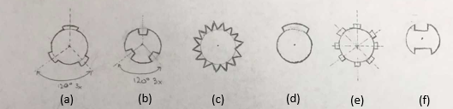

Figure 8: Various shaft design concepts

Table 8: Pugh Matrix of various shaft design concepts

|  |  |  |  |  |  |  |  |
| --- | --- | --- | --- | --- | --- | --- | --- |
| Shaft Selection | | | | | | |  |
| Part Name | C  CCost | Durability | Weight | Manufacturing Time | Variable Attachments | Symmetry | Total |
| A | 44 | 3 | 1 | 0 | 2 | 2 | 12 |
| B | 44 | 3 | 2 | 0 | 2 | 2 | 13 |
| C | 11 | 4 | 1 | 0 | 5 | 4 | 15 |
| D | 44 | 1 | 1 | 0 | 0 | 0 | 6 |
| E | 55 | 4 | 1 | 0 | 5 | 4 | 19 |
| F | 44 | 2 | 2 | 0 | 2 | 2 | 12 |

Looking at each individual criteria, cost was rated by considering the raw material that would need to be purchased to manufacture the design, as well as the complexity. Parts A, B, D, and F received the second highest rating as they are relatively simple to create based off similar diameter shafts. The shape in C would be the most expensive as it is the least common and the gear in E is the most commonly produced spline shaft making it the cheapest. It is important to note that spline shafts are too complex to be produced with the machines at the FAMU-FSU College of Engineering so the part will be ordered and the most abundant will be the cheapest. The durability of the product takes into consideration the quantity of teeth and internal versus external teeth arrangement. As Part D only has one tooth on the shaft, if that tooth were to yield, the disk stack would slip much easier. Conversely, possessing multiple teeth would enable stress concentrations to be more distributed and help minimize the potential for slip between the disks and shaft. As the weight of each shaft is almost identical for a given diameter, weight was considered based on internal versus external teeth. With internal teeth, there would be less material than with external teeth, leading to less weight. As this insubstantial weight difference possesses only a slight bit of significance in our application, the weight was rated in a manner to minimize its overall effect in the end result. Manufacturing time is not considered as the part will need to be ordered as stated before. Variable attachments would permit a staggered pattern in the disk stack, and thus allow further testing of different disk stack patterns to be accomplished. Parts C and E would have the availability to stagger the disks only a slight amount and therefore received a higher rating. Parts A, B, and F would allow partially staggered disks, while Part D does not permit any fluctuation in offsetting the disks; it received a zero in this category. Symmetry will also play a significant role in the selection process as it can help reduce the amount of wobble and vibration in the disk stack as it spins at high rpms. In this category, Parts C and E are the most symmetric and thus the best in this category. Alternatively, Part D is minimally symmetric and should not be used in this application.

As a result of the previous analysis and Pugh Matrix represented in Table 8, the most suitable shaft idea appears to be Part E. This idea is not overly complicated to purchase/manufacture, permits disks to be attached at variable angles, and possesses a highly symmetric design.

**Bearing Selection.**

Three different types of bearings, ball bearing, straight roller bearing, and a tapered roller bearing, were considered for this project and weighed in Table 9 below.

Table 9: Pugh Matrix for Bearings

|  |  |  |  |  |  |
| --- | --- | --- | --- | --- | --- |
| Bearings | | | | | |
| Part Name | Cost | Durability | Weight | Manufacturing Time | Total |
| Straight Roller Bearing | 4 | 4 | 0 | 0 | 8 |
| Tapered Roller Bearing | 3 | 5 | 0 | 0 | 8 |
| Ball Bearing | 5 | 4 | 0 | 0 | 9 |

Ball bearings are the most common and cheapest bearings, and in low-load applications are sufficient in handling both axial and radial loads. Due to a singular point of contact, they can be prone to deformation in higher loads. Straight roller bearings have a line of contact rather than a singular point, making them better equipped to handle high radial loads. However, due to one less degree of freedom this sacrifices ability to withstand axial loads. For a tesla pump, radial load is a larger concern than axial due to the high RPM shaft speeds. They are however slightly more expensive than ball bearings. Tapered roller bearings are like straight roller bearings, except the rollers are inclined at an angle relative to the axis. Because of this, they are able to handle high axial and radial loads. They are however, the most expensive of the bearings.

Considering these factors outlined in the above Pugh matrix, ball bearings seem like the best choice. Our tesla pump is unlikely to experience substantially high axial or radial loads, so it would be best to choose the cheaper option for initial testing. This will be reconsidered should the ball bearing prove insufficient to handle the loads.

**Materials Selection.**

Two stainless steel alloys, an aluminum alloy, and teflon were considered for the material the components will be composed of. Table 10 below shows the Pugh Matrix comparison for the various materials.

Table 10: Material Selection for Tesla Pump Construction

|  |  |  |  |  |  |  |
| --- | --- | --- | --- | --- | --- | --- |
| Material Selection | | | | | | |
| Part Name | Cost | Durability | Weight | Coef. of Thermal Expansion | Cryogenic Use | Total |
| SS 316 | 3 | 4 | 1 | 4 | 5 | 17 |
| SS 304 | 3 | 4 | 1 | 3 | 5 | 16 |
| AL 7075 | 4 | 5 | 3 | 3 | 0 | 15 |
| Teflon | 5 | 1 | 3 | 1 | 5 | 15 |

Various characteristics have been considered when selecting material for the design components. For the cost, most metals were roughly the same price, stainless steels being roughly 1.5 times the cost of aluminum and aluminum being 1.5 the cost of Teflon. For durability, aluminum produced the best rating with the highest yield strength, followed closely by stainless steel. The teflon was dismally low compared to the metals in this category. The weights were roughly the same for the teflon and aluminum, but the stainless steel was approximately 3 times denser, making stainless steel heavier overall. The coefficient of thermal expansion was roughly the same for the metals but again surprisingly high for the teflon. Of the characteristics, cryogenic use is considered the most important as it is critical for this project to function in cryogenic fluids. Aluminum’s lowest operating temperature was reported higher than the temperature for liquid nitrogen, making it not useable for this project. Based on the numbers found, SS 316 would be the most optimal material to be used in constructing the Tesla Pump system.

It is also important to note that the material chosen, will likely be the same for most or all of the components. Due to the extremely low temperature of liquid nitrogen, thermal contraction will be very prevalent. Using different materials would cause possible deformations, at places where a tight fit is desired

**Conclusion of Concept Selection.**

Based on the concepts that have been considered and selected for use in the design, this is what the final Tesla Pump system will consist of. The housing that best meets the criteria needed to support the success of the project is the divergent housing with two inlets and one outlet, as well as the combination of bearing locations. When designing the disks, the most effective design was a combination of the notches located around the perimeter of the disk, with either the rectangular or teardrop hole designs considered in the Pugh Matrix. Variable disk spacing was chosen for loading the disks onto the shaft specified for disk use. For the nozzle design, the best to accomplish the necessary pressure rise of the pump was the round nozzle. For the shaft of the system the best selection ended up being the spline shaft concept E, as it allowed for the most versatility among the disc placement and stress distribution. The bearings being used for the project were considered next, and of the three choices outlined, the ball bearing was chosen because the loads in this application would be relatively small, and they are the cheapest bearings to acquire. Finally, the best material for the overall Tesla Pump design was determined to be Stainless Steel 316, for it successfully fulfills the cryogenic function of the design.

## 1.8 Project Plan

The current project plan will help the team set milestones that will be achieved during the semester. This will help keep the project on track and within the allotted time. Below, in Figure 9, is a Gantt chart depicting the project plan for Team 12. 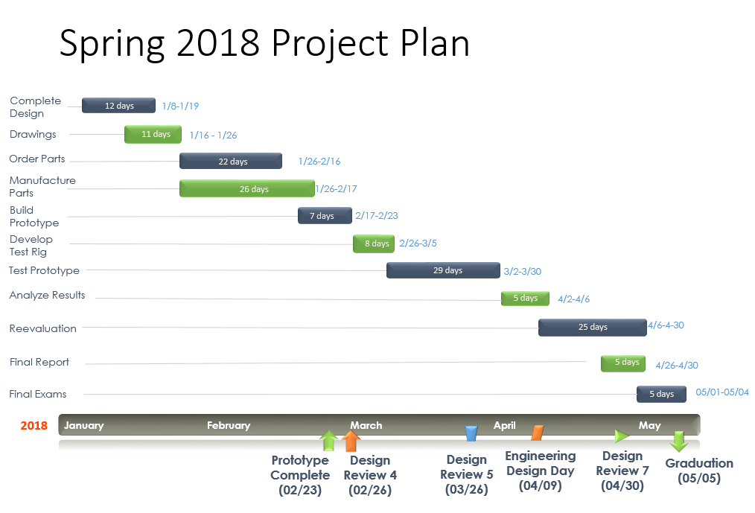

Figure 9: Gantt Chart of Spring 2018 Project Plan

Upon returning from winter break, the team has been working to complete the entire design and develop all associated drawings. After confirmation of the design, the team will seek out and order the corresponding parts, which will enable manufacturing and construction to begin shortly after. Some issues or challenges that may arise in the project are: manufacturing the housing, preventing leaks, balancing the disks, and designing a test rig that will allow useful data collection. The team will attempt to work through each situation as it occurs in the most efficient manner in order to stay on the planned trajectory. Once the pump is assembled, the team will enter the testing phase, which includes development of a test rig that will suit the project. Upon completion of a functional test rig, testing may begin, and the team can ultimately gather data associated with the design. At this point, correlations can be made to help identify the ideal disk spacing. This would produce the desired results at given rpm. Upon analyzing the data, flaws may be identified, enabling future iterations of the pump design. These will be considered and adjusted accordingly to optimize the complete design in the reevaluation phase. A final report detailing the results and conclusions of the project will be generated the week prior to the spring semester’s final exam week.

For this spring semester, the team has taken up new tasks to distribute the work load. Now that a lot of documentation has been collected, it has been determined that a website would be useful to record and display project information in an easily accessible manner. The lead role of webmaster has been designated to Eric Goff. The design phase for the project is underway currently with parts being generated in CAD, the lead for this role was filled by Garrett Hart in association with Christopher Salim. As CAD parts are generated the task of researching and ordering the needed parts and material to assemble the pump was delegated to Patrick Duggan. Preparing and editing the finalized documents was performed by Thomas Kline.

The Budget for this project has been set at $500.00. The team expects to complete the project within this budget. It has been determined that the majority of the funds will be allocated to purchasing material for parts. The rest of the budget will be spent assembling and testing the design.

# Chapter Two: EML 4552C

## 2.1 Spring Plan

### Project Plan.

### Build Plan.

# Appendices

# Appendix A: Code of Conduct

**Mission Statement**

Members of Team 12 shall strive to maintain excellence, work towards a solution for our product in a responsible way, ensure all members of the team’s opinions are heard, and that the sponsors’ desires are carried out in the best manner possible.

**Member Expectations**

         All members of Team 12 are expected to embrace the principles of our code of conduct while maintaining a transparent and open mind when working as a team.

**The team members shall:**

1.       Show respect in all team meetings.

2.       Act with integrity in all dealings with the project.

3.       Ensure the ethics of the team and engineering community are held up as the governing standard.

4.       Perform work responsibly for our sponsor in an efficient manner.

**Member Roles**

**Team Leader**: Patrick Duggan

Shall be responsible for heading meetings, checking progress of other project related quasi-committees, and communicating with the professor and sponsor. Additionally, the team leader is responsible for advocating teamwork and harmony within the group in order to work towards the team’s common goals.

**Secretary**: Eric Goff

Shall be responsible for taking notes during meetings and providing a recap of the last meeting.

**Lead ME**: Thomas Kline

Shall be in charge of ensuring the calculations are accurate. Should have a working knowledge of the design and its functions. Should work closely with Design Coordinator to ensure design is functional and fits parameters.

**Treasurer**: Garrett Hart

Shall be responsible for keeping the team within the allotted budget. Making sure that materials and parts the team buys are a reasonable price and of acceptable quality. All purchases must be approved by Treasurer before made.

**Design Coordinator:** Chris Salim

Shall be responsible for all drafting and computer aided design, including the production of detailed drawings. Also in charge of machining the designed CAD parts. Responsible for working with Lead ME to ensure design is functional and fits parameters.

**All Team Members:**

Shall perform unforeseen tasks, when the need rises. Shall be able to take notes in the absence of the Secretary and shall be able to make approved purchases on the behalf of the team while communicating with the leader and the treasurer. Every team member is encouraged to help out in the roles of other members.

**Decision Making**

1.       Decisions that require the expenditure of money or alterations to a design shall require a vote.

2.       To hold a vote at least 4 members must be present and fully understand the decision being voted on.

3.       The voting decision should have a majority in such cases (at least 51% in favor) to pass.

**Informal Team Meetings**

1. The Group shall meet three times a week: Monday at 5:00 PM, and Tuesday/Thursday during and after the allotted class time.

2. Each member is responsible for being present at those meetings and shall be required to make up for the time that is missed. Repeated absences will not be tolerated unless under extreme circumstances at the discretion of the team.

3. Sunday shall be reserved for an optional workday if needed to accomplish project milestones.

**Communication**

Outside of team meetings, class, staff meetings, and other activities, the team will communicate primarily through a group text message, and secondarily by e-mail. It is expected that each member check their e-mail twice a day and pay attention to the group chat for updates. If a team member must miss a meeting, it is expected that they alert the group chat at least 24 hours before the scheduled time. Presentations and all other files will be sent through e-mail.

**Ethics**

Team members must read, understand, and follow the NSPE Engineering Code of ethics, as it is their responsibility to fulfil their obligations to the public, the client, the employer, and the profession.

**Dress Code**

Team and staff meetings will be held in casual attire. Sponsor meetings shall be required to wear business casual to formal attire as decided by the team to fit the event. Presentations will require formal attire.

**Conflict Resolution**

If the event rises where there is a disagreement amongst the members, the issue shall be brought up in the team meeting and both parties shall be allowed to defend their side of the argument. The team will decide as a whole on the issue and explain their reasoning behind the decision. If the member still feels that the issue has not been resolved then the team will set a time to speak with Dr. McConomy to resolve such issue.

**Closing**

Our code of conduct shall remain our guiding compass in all matters of business that revolve around the assigned project of Team 12. By signing this document you have read, fully understand, and agree to uphold the code of conduct and its requirements.

**Signing**



# 

# Appendix B: Functional Decomposition

# Appendix C: Target Catalog

|  |  |  |
| --- | --- | --- |
| **Targets** | **Value** | **Unit** |
| Volumetric Flow Rate | 15 | gpm |
| Pressure Rise | 5 | psi |
| Overall Diameter | 4 | in |
| Disk Spacing | 1 thru 10 | Thou |
| The metrics below depend heavily on disk spacing | | |
| Fluid Mixing | 5 | psi |
| Adjust Working Fluid | 5 | psi |
| Control Flow | 15 | gpm |
| Convey Working Fluid | 15 | gpm |
| Motor RPM | 6,000 thru 10,000 | rpm |
| Spin Disk Stack | 10 thru 20 | rad/s^2 |
| Steady Rotation | ~60 | dB |
| Consume Minimal Power | 0.33 | hp |

# References

McConomy, S. (2017, September 19). Functional Decomposition and Task Analysis. Lecture presented at FAMU-FSU College of Engineering, Tallahassee.